Form Submit Module Manual

# Setup:

* Software recommend: VSCode.
* Extract folder, open it via VSCode
* Open Project folder:
* On the terminal, type: ng serve –port <port_number>

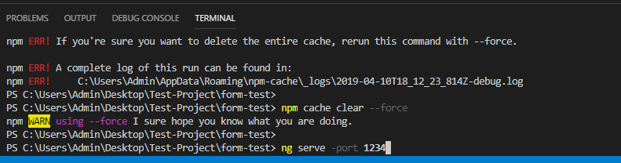

* Open your browser and type: *localhost:<port_number>*

